EXPERIMENT 4::

# Import necessary libraries

import numpy as np

import pandas as pd

from sklearn.model_selection import train_test_split

from sklearn.linear_model import LinearRegression

from sklearn.metrics import mean_squared_error, r2_score

import matplotlib.pyplot as plt

# Load the California Housing dataset

from sklearn.datasets import fetch_california_housing

housing = fetch_california_housing()

# Create a DataFrame from the dataset

data = pd.DataFrame(housing.data, columns=housing.feature_names)

data['MedHouseVal'] = housing.target

# Define the features (X) and the target (y)

X = data.drop('MedHouseVal', axis=1)

y = data['MedHouseVal']

# Split the data into training and testing sets

X_train, X_test, y_train, y_test = train_test_split(X, y, test_size=0.2, random_state=42)

# Create a linear regression model

model = LinearRegression()

# Train the model

model.fit(X_train, y_train)

# Make predictions on the test set

y_pred = model.predict(X_test)

# Evaluate the model

mse = mean_squared_error(y_test, y_pred)

r2 = r2_score(y_test, y_pred)

print(f"Mean Squared Error: {mse}")

print(f"R-squared: {r2}")

# Plotting the results

plt.scatter(y_test, y_pred)

plt.xlabel("Actual Prices")

plt.ylabel("Predicted Prices")

plt.title("Actual Prices vs Predicted Prices")

plt.show()

OUTPUT:

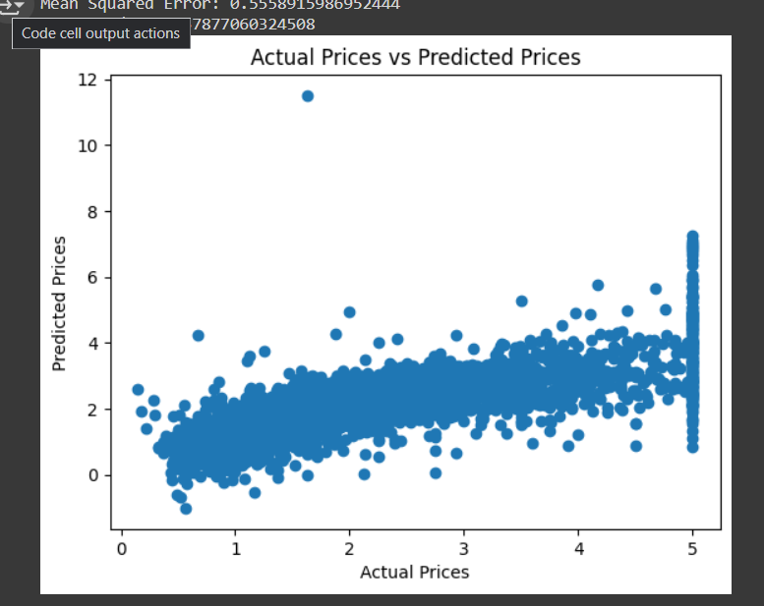

EXPERIMENT 5::

# Import necessary libraries

import numpy as np

import pandas as pd

from sklearn.model_selection import train_test_split

from sklearn.linear_model import LogisticRegression

from sklearn.metrics import accuracy_score, confusion_matrix, classification_report, roc_curve, roc_auc_score

import matplotlib.pyplot as plt

# Load the Breast Cancer dataset

from sklearn.datasets import load_breast_cancer

data = load_breast_cancer()

# Create a DataFrame from the dataset

df = pd.DataFrame(data.data, columns=data.feature_names)

df['target'] = data.target

# Define the features (X) and the target (y)

X = df.drop('target', axis=1)

y = df['target']

# Split the data into training and testing sets

X_train, X_test, y_train, y_test = train_test_split(X, y, test_size=0.2, random_state=42)

# Create a logistic regression model

model = LogisticRegression(max_iter=10000)

# Train the model

model.fit(X_train, y_train)

# Make predictions on the test set

y_pred = model.predict(X_test)

# Evaluate the model

accuracy = accuracy_score(y_test, y_pred)

conf_matrix = confusion_matrix(y_test, y_pred)

class_report = classification_report(y_test, y_pred)

roc_auc = roc_auc_score(y_test, model.predict_proba(X_test)[:, 1])

print(f"Accuracy: {accuracy}")

print(f"Confusion Matrix:\n{conf_matrix}")

print(f"Classification Report:\n{class_report}")

print(f"ROC AUC: {roc_auc}")

# Plotting the ROC curve

fpr, tpr, _ = roc_curve(y_test, model.predict_proba(X_test)[:, 1])

plt.plot(fpr, tpr, marker='.')

plt.xlabel("False Positive Rate")

plt.ylabel("True Positive Rate")

plt.title("ROC Curve")

plt.show()

OUTPUT:

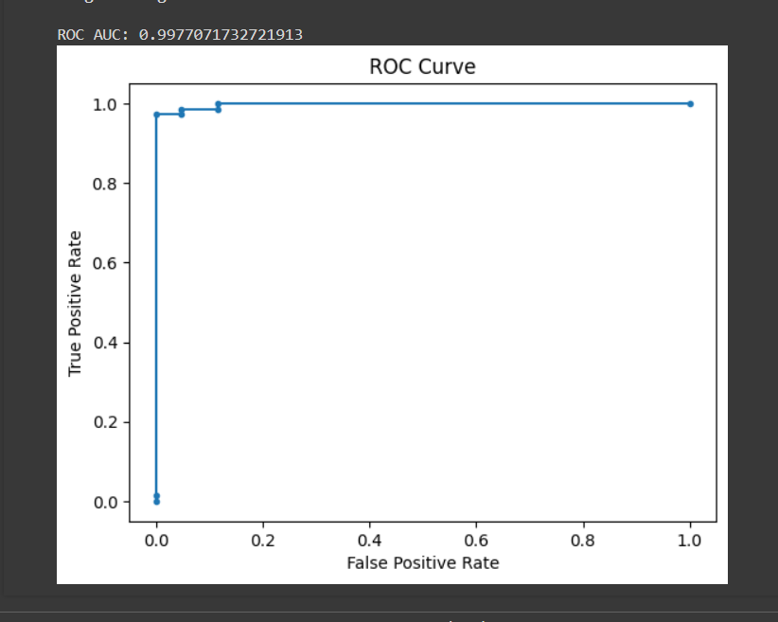

1. EXPERIMENT 6::

# Import necessary libraries

import numpy as np

import pandas as pd

from sklearn.model_selection import train_test_split

from sklearn.neighbors import KNeighborsClassifier

from sklearn.metrics import accuracy_score

# Load the Iris dataset

from sklearn.datasets import load_iris

iris = load_iris()

# Create a DataFrame from the dataset

data = pd.DataFrame(iris.data, columns=iris.feature_names)

data['target'] = iris.target

# Define the features (X) and the target (y)

X = data.drop('target', axis=1)

y = data['target']

# Split the data into training and testing sets

X_train, X_test, y_train, y_test = train_test_split(X, y, test_size=0.2, random_state=42)

# Create a KNN model

knn = KNeighborsClassifier(n_neighbors=3) # You can choose a different value for n_neighbors

# Train the model

knn.fit(X_train, y_train)

# Make predictions on the test set

y_pred = knn.predict(X_test)

# Evaluate the model's accuracy

accuracy = accuracy_score(y_test, y_pred)

print(f"Accuracy: {accuracy}")

OUTPUT:

Confusion Matrix:

[[14 1]

[ 2 13]]

Accuracy: 0.9

B)# Import necessary libraries

import numpy as np

import pandas as pd

from sklearn.model_selection import train_test_split

from sklearn.naive_bayes import GaussianNB

from sklearn.metrics import accuracy_score

# Load the Iris dataset

from sklearn.datasets import load_iris

iris = load_iris()

# Create a DataFrame from the dataset

data = pd.DataFrame(iris.data, columns=iris.feature_names)

data['target'] = iris.target

# Define the features (X) and the target (y)

X = data.drop('target', axis=1)

y = data['target']

# Split the data into training and testing sets

X_train, X_test, y_train, y_test = train_test_split(X, y, test_size=0.2, random_state=42)

# Create a Naive Bayes model

model = GaussianNB()

# Train the model

model.fit(X_train, y_train)

# Make predictions on the test set

y_pred = model.predict(X_test)

# Evaluate the model's accuracy

accuracy = accuracy_score(y_test, y_pred)

print(f"Accuracy: {accuracy}")

OUTPUT:

[[12 2]

[ 0 11]]

Accuracy: 0.92

C)# Import necessary libraries

import numpy as np

import pandas as pd

from sklearn.model_selection import train_test_split

from sklearn.linear_model import LogisticRegression

from sklearn.metrics import accuracy_score

# Load the Iris dataset

from sklearn.datasets import load_iris

iris = load_iris()

# Create a DataFrame from the dataset

data = pd.DataFrame(iris.data, columns=iris.feature_names)

data['target'] = iris.target

# Define the features (X) and the target (y)

X = data.drop('target', axis=1)

y = data['target']

# Split the data into training and testing sets

X_train, X_test, y_train, y_test = train_test_split(X, y, test_size=0.2, random_state=42)

# Create a Logistic Regression model

model = LogisticRegression(max_iter=200)

# Train the model

model.fit(X_train, y_train)

# Make predictions on the test set

y_pred = model.predict(X_test)

# Evaluate the model's accuracy

accuracy = accuracy_score(y_test, y_pred)

print(f"Accuracy: {accuracy}")

OUTPUT:

Confusion Matrix:

[[22 2]

[ 3 18]]

Accuracy: 0.8888888888888888

D)# Import necessary libraries

import numpy as np

import pandas as pd

from sklearn.model_selection import train_test_split

from sklearn.tree import DecisionTreeClassifier

from sklearn.metrics import accuracy_score

# Load the Iris dataset

from sklearn.datasets import load_iris

iris = load_iris()

# Create a DataFrame from the dataset

data = pd.DataFrame(iris.data, columns=iris.feature_names)

data['target'] = iris.target

# Define the features (X) and the target (y)

X = data.drop('target', axis=1)

y = data['target']

# Split the data into training and testing sets

X_train, X_test, y_train, y_test = train_test_split(X, y, test_size=0.2, random_state=42)

# Create a Decision Tree model

model = DecisionTreeClassifier(random_state=42)

# Train the model

model.fit(X_train, y_train)

# Make predictions on the test set

y_pred = model.predict(X_test)

# Evaluate the model's accuracy

accuracy = accuracy_score(y_test, y_pred)

print(f"Accuracy: {accuracy}")

OUTPUT:

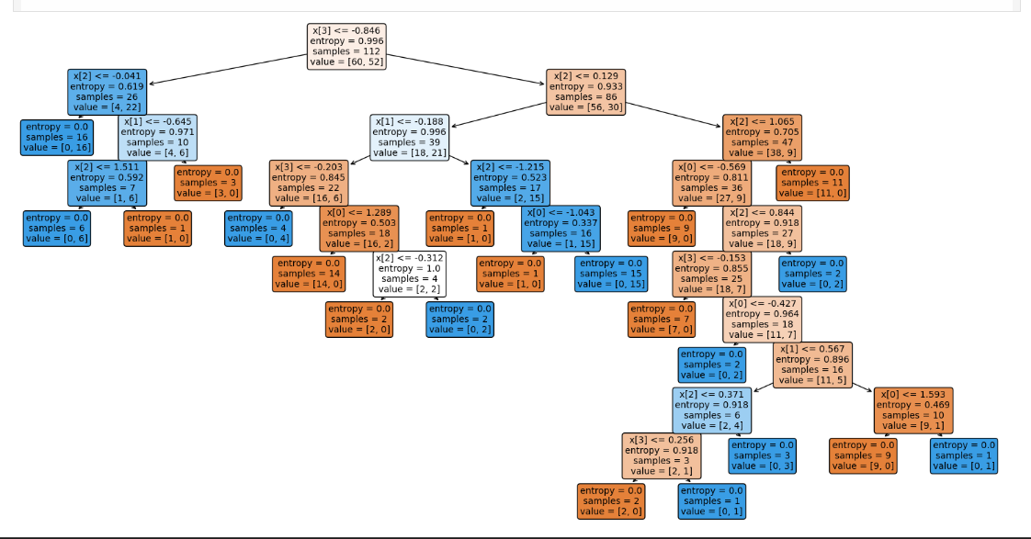

Confusion Matrix:

[[ 9 5]

[ 7 17]]

Accuracy: 0.6842105263157895

E)# Import necessary libraries

import numpy as np

import pandas as pd

from sklearn.model_selection import train_test_split

from sklearn.svm import SVC

from sklearn.metrics import accuracy_score

# Load the Iris dataset

from sklearn.datasets import load_iris

iris = load_iris()

# Create a DataFrame from the dataset

data = pd.DataFrame(iris.data, columns=iris.feature_names)

data['target'] = iris.target

# Define the features (X) and the target (y)

X = data.drop('target', axis=1)

y = data['target']

# Split the data into training and testing sets

X_train, X_test, y_train, y_test = train_test_split(X, y, test_size=0.2, random_state=42)

# Create an SVM model

model = SVC()

# Train the model

model.fit(X_train, y_train)

# Make predictions on the test set

y_pred = model.predict(X_test)

# Evaluate the model's accuracy

accuracy = accuracy_score(y_test, y_pred)

print(f"Accuracy: {accuracy}")

OUTPUT:

Confusion Matrix:

[[17 3]

[ 3 15]]

Accuracy: 84.21%

F)# Import necessary libraries

import numpy as np

import pandas as pd

from sklearn.model_selection import train_test_split

from sklearn.ensemble import RandomForestClassifier

from sklearn.metrics import accuracy_score

# Load the Iris dataset

from sklearn.datasets import load_iris

iris = load_iris()

# Create a DataFrame from the dataset

data = pd.DataFrame(iris.data, columns=iris.feature_names)

data['target'] = iris.target

# Define the features (X) and the target (y)

X = data.drop('target', axis=1)

y = data['target']

# Split the data into training and testing sets

X_train, X_test, y_train, y_test = train_test_split(X, y, test_size=0.2, random_state=42)

# Create a Random Forest model

model = RandomForestClassifier(random_state=42)

# Train the model

model.fit(X_train, y_train)

# Make predictions on the test set

y_pred = model.predict(X_test)

# Evaluate the model's accuracy

accuracy = accuracy_score(y_test, y_pred)

print(f"Accuracy: {accuracy}")

OUTPUT:

Confusion Matrix:

[[12 0 0]

[ 0 13 0]

[ 0 1 12]]

Accuracy: 0.9736842105263158